長庚大學資訊工程學系 一百零六學年度上學期 計算機圖學課程小考試題I
上課班級: 三年甲班 授課老師: 林俊淵
受測範圍: Slides 1~5

- Please write an OpenGL program to draw the picture. (70 points, a: 10 points, b: 15 points, c: 20 points, d: 25 points)

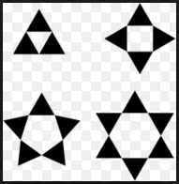
a
b
c
d

- Please write an OpenGL program to draw the picture (a), and then using gluOrtho2D to change the picture(a) as pictures (b),(c) and (d). (50) points
- 20 points (b) 10 points
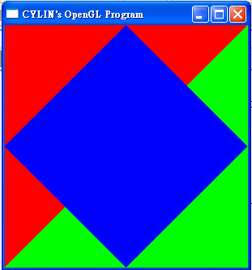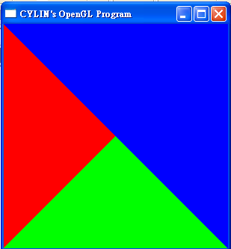

畫出全部答案後, 請舉手由老師過去評分. 請每一小題都要記得存檔.

